Usability test script
(Raw notes: Page 4 onwards)

 Web browser should be open to Google or some other “neutral” page

Hi, ___________. My name is ___________, and I’m going to be walking you through this session today.

Before we begin, I have some information for you, and I’m going to read it to make sure that I cover everything.
You probably already have a good idea of why we asked you here, but let me go over it again briefly. We’re asking people to try using a Web site that I’ve been working on so we can see whether it works as intended. The session should take about 10 minutes.

The first thing I want to make clear right away is that we’re testing the site, not you. You can’t do anything wrong here. In fact, this is probably the one place today where you don’t have to worry about making mistakes.

As you use the site, I’m going to ask you as much as possible to try to think out loud: to say what you’re looking at, what you’re trying to do, and what you’re thinking. This will be a big help to me.

Also, please don’t worry that you’re going to hurt my feelings. I am doing this to improve the site, so I need to hear your honest reactions.

If you have any questions as we go along, just ask them. I may not be able to answer them right away, since I’m interested in how people do when they don’t have someone sitting next to them to help. But if you still have any questions when we’re done I’ll try to try to answer them then. And if you need to take a break at any point, just let me know.

If you would, I’m going to ask you to sign a simple consent form for me. It just confirms that you have agreed to participate in this study to help me work out what works the best in each web design and that the information collected is for class work only.

Do you have any questions so far?

❑ Give them the consent form and a pen

OK. Before we look at the site, I’d like to ask you just a few quick questions.

First, what’s your occupation? What do you do all day?

Now, roughly how many hours a week altogether—just a ballpark estimate— would you say you spend using the Internet, including Web browsing and email, at work and at home?

And what’s the split between email and browsing—a rough percentage?

What kinds of sites are you looking at when you browse the Web?

Do you have any favourite Web sites?

OK, great. We’re done with the questions, and we can start looking at things.
What kinds of sites are you looking at when you browse the Web?

Do you have any favourite Web sites?

OK, great. We’re done with the questions, and we can start looking at things.

❑ Click on the bookmark for the site’s Home page.

First, I’m going to ask you to look at this page and tell me what you make of it:

-what strikes you about it
-whose site you think it is
-what you can do here
-what it’s for

You can scroll if you want to, but don’t click on anything yet

Thanks. Now I’m going to ask you to try doing some specific tasks. I’m going to read each one out loud.

Raw Notes:

Participants’ information: (written by Wang Siao Shuen)

Questions:
- What’s your occupation? What do you do all day?

- Roughly how many hours a week altogether—just a ballpark estimate— would you say you spend using the Internet, including Web browsing and email, at work and at home?

- What’s the split between email and browsing—a rough percentage?

- What kinds of sites are you looking at when you browse the Web?

- Do you have any favourite Web sites?

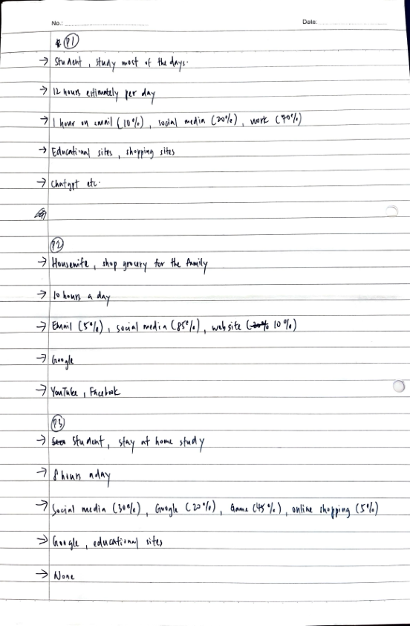

Website Tasks
Don’t read this bit (Develop a list of 8 tasks for the user to perform. Choose a few tasks that cannot be answered within the website so that you can see how the user searches for information and what their backup strategies are when their first attempt fails. Determine the amount of time you will allow for each task and record the actual time it takes for the user to complete the task.)

Participant 1:
1. Show me what services do Aspect offer.
Users Comments:
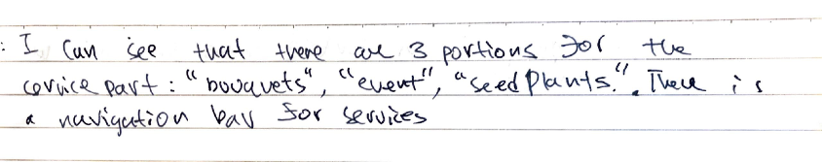
Testers Comments:
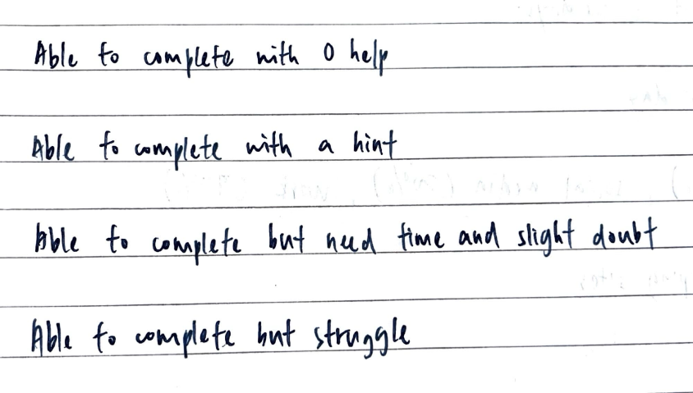

2. Show me where to learn more about Aspect.
Users Comments:
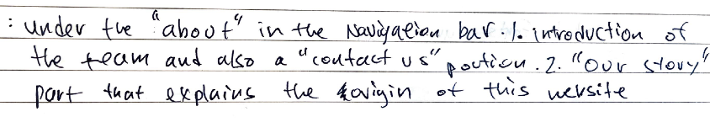
Testers Comments:

3. Show me how to book a consultation with the florist.
Users Comments:
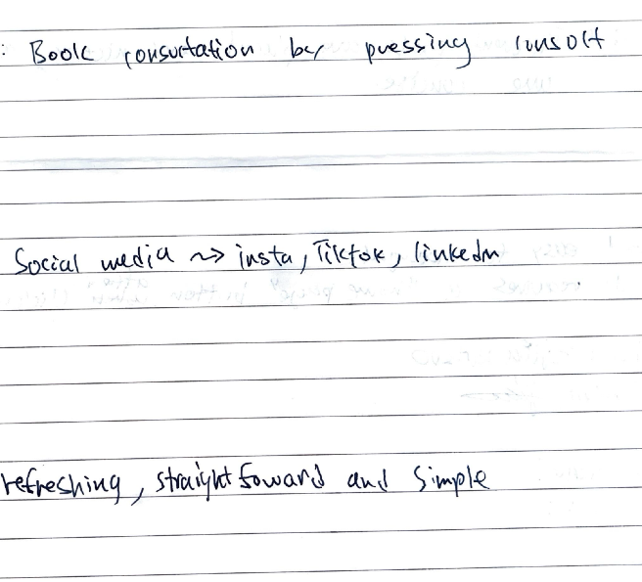

Testers Comments:

4. Show me some ways you would connect with the brand.
Users Comments:
Testers Comments:

5. Describe what do you think this brand stands for. (Values etc.)
Users Comments:
Testers Comments:

6. Describe how you feel about the colours used.
Users Comments:
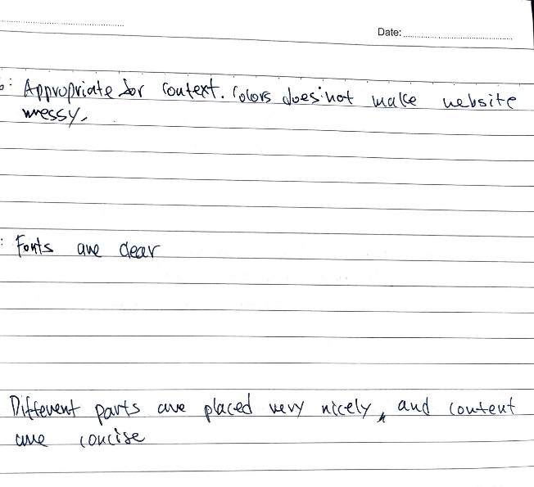
Testers Comments:

7. Describe how the fonts and text layout make you feel.
Users Comments:
Testers Comments:

8. Tell me how the visual design influences your first impression of the brand.
Users Comments:
Testers Comments:

Participant 2:

1. Show me what services do Aspect offer.
Users Comments:
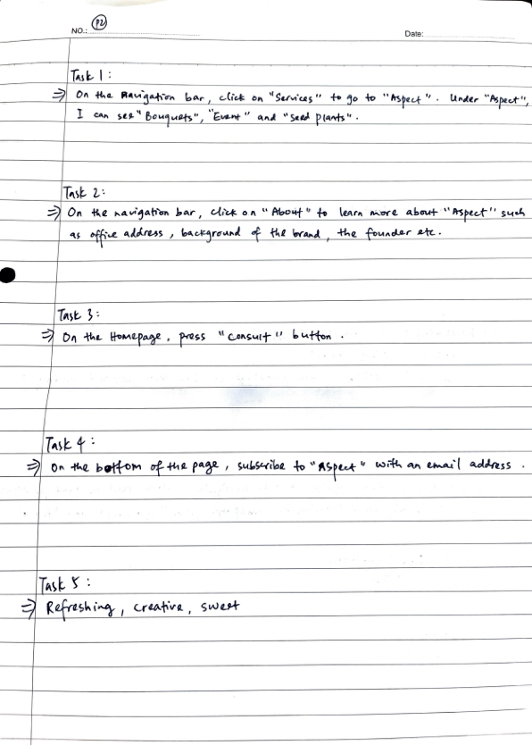
Testers Comments:

2. Show me where to learn more about Aspect.
Users Comments:
Testers Comments:

3. Show me how to book a consultation with the florist.
Users Comments:
Testers Comments:

4. Show me some ways you would connect with the brand.
Users Comments:
Testers Comments:

5. Describe what do you think this brand stands for. (Values etc.)
Users Comments:
Testers Comments:

6. Describe how you feel about the colours used.
Users Comments:
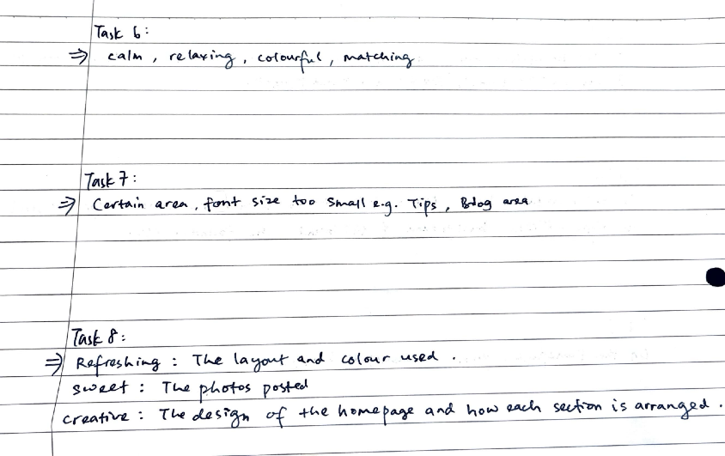
Testers Comments:

7. Describe how the fonts and text layout make you feel.
Users Comments:
Testers Comments:
8. Tell me how the visual design influences your first impression of the brand.
Users Comments:

Testers Comments:

Participant 3:

1. Show me what services do Aspect offer.
Users Comments:
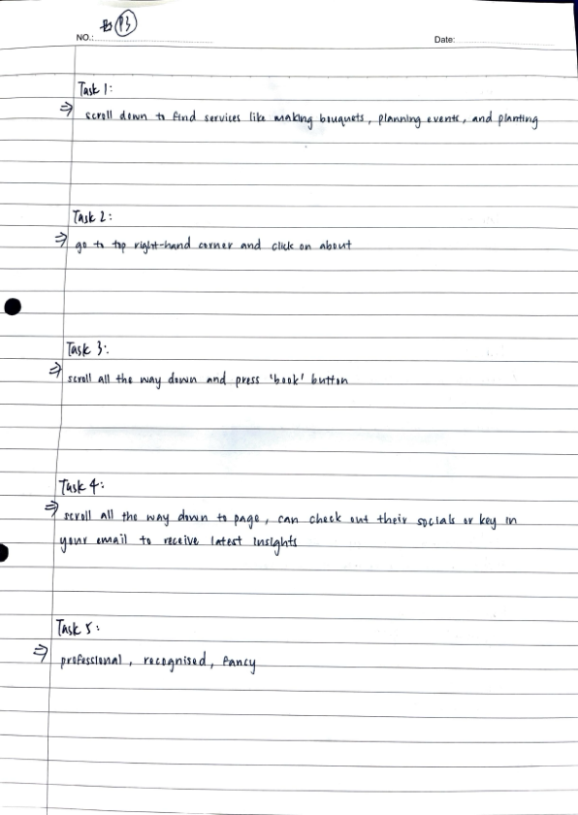
Testers Comments:

2. Show me where to learn more about Aspect.
Users Comments:

Testers Comments:

3. Show me how to book a consultation with the florist.
Users Comments:
Testers Comments:

4. Show me some ways you would connect with the brand.
Users Comments:
Testers Comments:

5. Describe what do you think this brand stands for. (Values etc.)
Users Comments:
Testers Comments:

6. Describe how you feel about the colours used.
Users Comments:
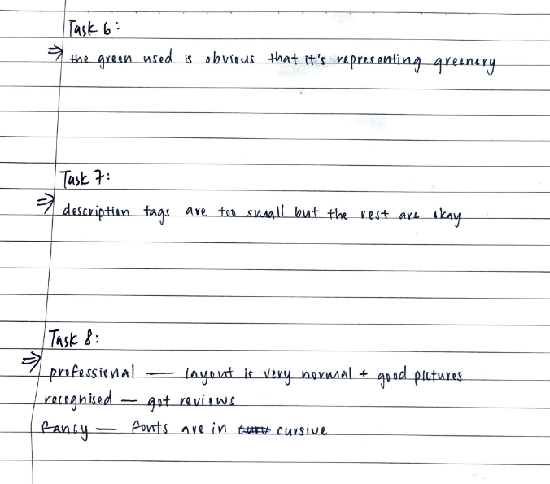
Testers Comments:

7. Describe how the fonts and text layout make you feel.
Users Comments:
Testers Comments:

8. Tell me how the visual design influences your first impression of the brand.
Users Comments:
Testers Comments:

Summary of Test Results
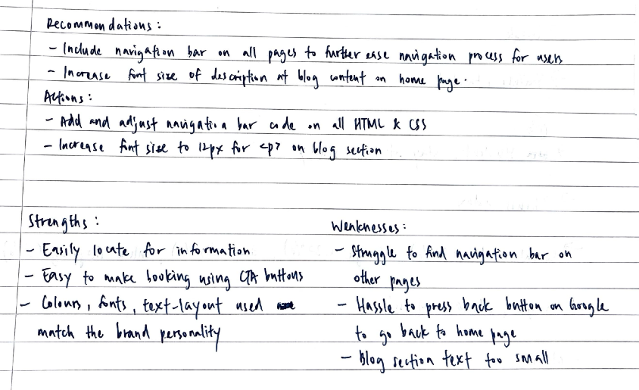

Conclusion

